AWS IAM GROUP & S3 READ-ONLY ACCESS
Practical Execution Report | SkillPilots
Prepared by: Sanika
Date of execution: 19 October 2026

1. Aim
To create an IAM user group, attach a read-only Amazon S3 policy, add an IAM user to the group, and verify S3 read/list access using the AWS Command Line Interface (CLI).

2. Requirements
- An AWS account with permission to manage IAM users, groups, and policies.
- AWS CLI installed on a Windows computer.
- A dedicated IAM user for the test.

3. Procedure

Step 1 — Review the task
The SkillPilots task asked for a new IAM group, a read-only S3 policy, a user in the group, and a CLI access test.

Step 2 — Create the IAM group
In AWS Console, open IAM → User groups → Create group. Enter Sanika-S3-Group and create the group.

Step 3 — Attach the policy
Open the group's Permissions tab and attach the AWS-managed policy AmazonS3ReadOnlyAccess. This policy provides read/list access to S3 resources covered by its permissions; it does not grant S3 write access.

Step 4 — Create the IAM user
Create the IAM user user_sanika. In the permissions step, add the user to the Sanika-S3-Group group.

Step 5 — Configure AWS CLI
Configure AWS CLI on Windows with credentials belonging to user_sanika and set the default region to ap-south-1 (Mumbai). Never publish secret access keys.

Step 6 — Verify the identity
Run aws sts get-caller-identity. The returned ARN identified the IAM user as arn:aws:iam::872376836627:user/user_sanika.

Step 7 — Test S3 listing
Run aws s3 ls and aws s3api list-buckets. Both commands completed without an authorization error. The list-buckets response returned an empty Buckets array, indicating there were no buckets in the account at that time.

Step 8 — Confirm group membership
Return to IAM → User groups and confirm Sanika-S3-Group shows one user.

4. Results / Observation
Test | Observed result | Status
IAM group | Sanika-S3-Group created | Completed
Group policy | AmazonS3ReadOnlyAccess attached | Completed
IAM user | user_sanika identified by AWS CLI | Completed
S3 listing | Commands succeeded; no buckets listed | Completed
Group membership | Group page showed 1 user | Confirmed

5. Conclusion
The IAM group Sanika-S3-Group was created and configured with AmazonS3ReadOnlyAccess. The IAM user user_sanika was used to run AWS CLI identity and S3 listing commands successfully. The S3 listing returned no buckets, but no error was reported. The group membership was also confirmed.

6. Screenshot Evidence
The following screenshots are labelled in execution order. The same image files are included in the Screenshots folder in this package.

Task instructions
The SkillPilots task requires creating an IAM group, attaching an S3 read-only policy, adding a user, and testing access using CLI.
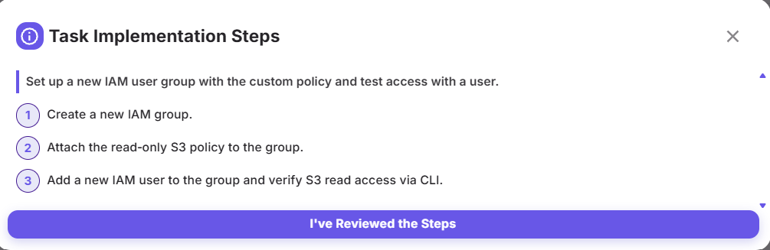

Create IAM group
The group name Sanika-S3-Group is entered in the Create user group form.
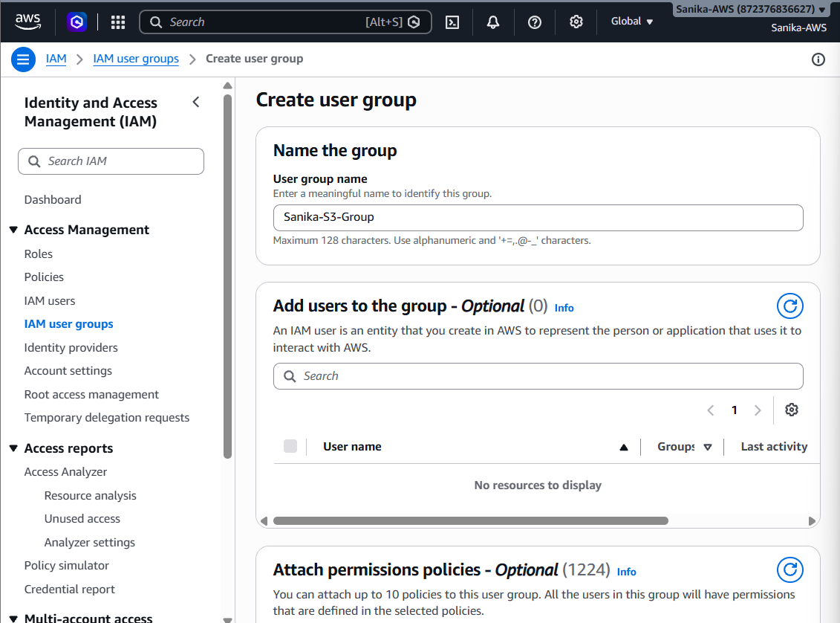

IAM group created
AWS confirms that Sanika-S3-Group was created successfully.
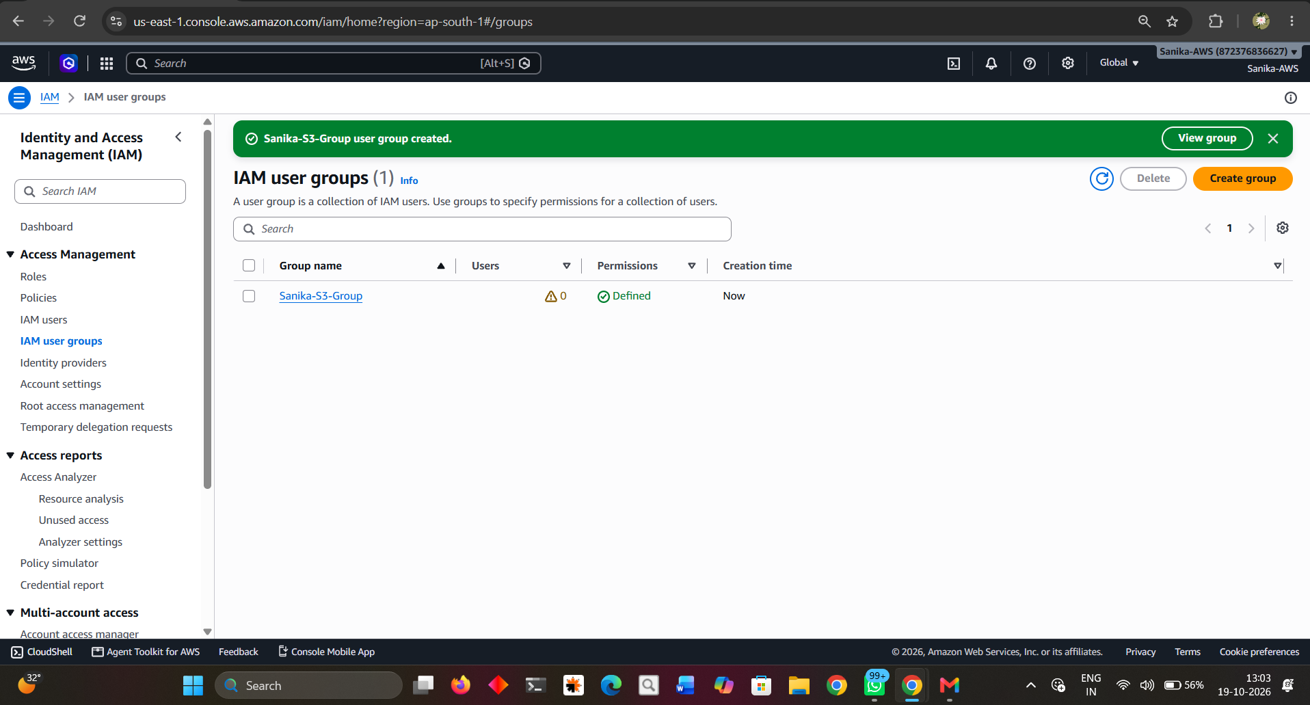

Read-only policy attached
The group's Permissions tab shows the AWS-managed AmazonS3ReadOnlyAccess policy.
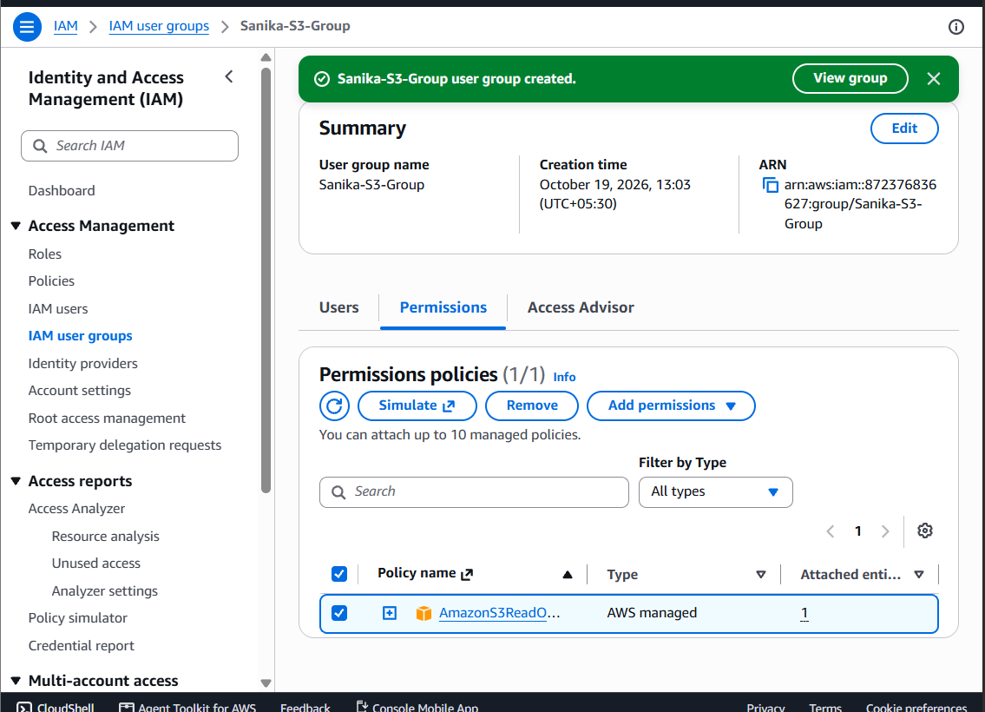

Create IAM user
The IAM user creation form shows the username user_sanika.
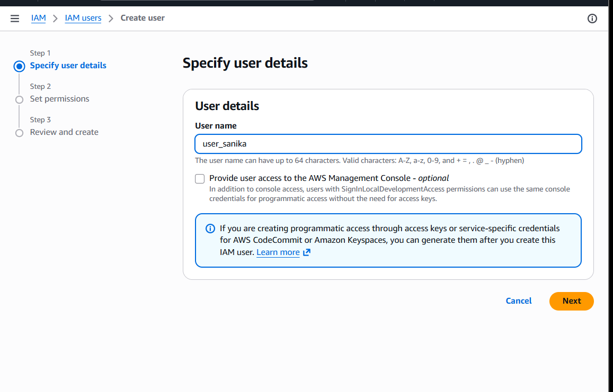

CLI identity and S3 listing
AWS CLI confirms the active identity is user_sanika. The aws s3 ls command returns without an error.
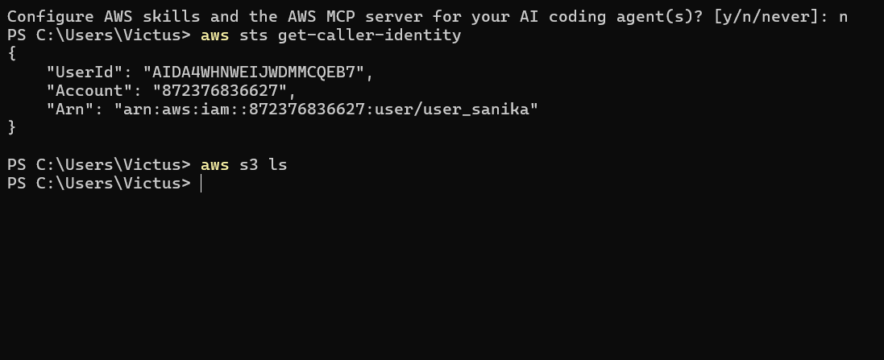

S3 API list-buckets test
aws s3api list-buckets returns a valid response with an empty Buckets array, meaning no S3 buckets are currently present.
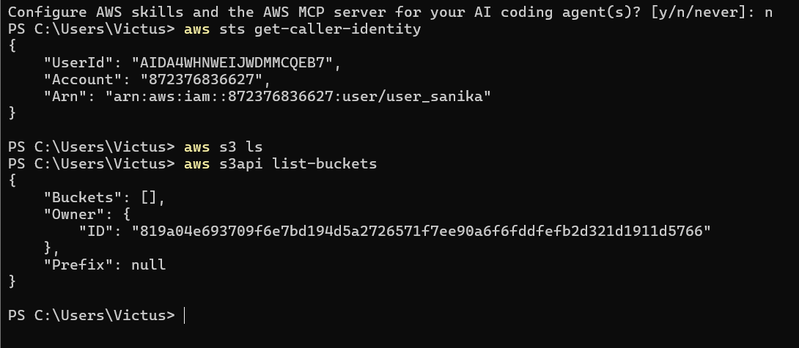

Group membership confirmed
The IAM user groups page shows Sanika-S3-Group has one user.
